Analysis Of The Design Requirements For 20 Watt Solar Panel And Led In The Design Of Public Street Lighting (Pju) Based On A Microcontroller Using Solar Cell

Riski mistal kadapi silalahi, Solly Aryza Lubis, Beni Satria

Abstract
Indonesia, with its tropical climate and year-round sunshine, holds great potential for developing renewable energy sources. Renewable energy plays a positive role as an alternative that needs to be developed to meet electricity needs, one of which is for Public Street Lighting (PJU). The implementation of solar-powered PJU (PJUTS) is one such alternative that can be offered. PJUTS utilizes sunlight as its energy source and batteries for energy storage, while making use of LED lights known for their environmental friendliness. This research aims to implement the design requirements of a solar panel and 20-watt LED lamp for a solar cell- based PJU design. Additionally, the study outlines the application and data collection methods of PJUTS using a watt meter. The main objective of this research is to determine the requirements for using a solar panel and a 20-watt LED lamp. The results of the study show that the PJUTS design with a 20-watt LED lamp can operate automatically. The lamp will turn off automatically when the charging process begins from the solar panel and will turn on automatically when the solar panel stops absorbing sunlight. Thus, this system offers an efficient and environmentally friendly solution for public street lighting in Indonesia.

Keyword : Solar Panels, Light Emitting Diodes, Solar Powered Public Street Lighting

Riski Mistal Kadapi Silalahi¹
¹Bachelor of Electrical Engineering, Universitas Pembangunan Panca Budi, Indonesia e-mail: rizkykadapi16@gmail.com¹
Solly Aryza Lubis², Beni Satria³
^{2,3}Master of Electrical Engineering, Universitas Pembangunan Panca Budi, Indonesia e-mail: sollyaryzalubis@dosen.pancabudi.ac.id², bsatria6@gmail.com³
2nd International Conference on Islamic Community Studies (ICICS)
Theme: History of Malay Civilisation and Islamic Human Capacity and Halal Hub in the Globalization Era https://proceeding.pancabudi.ac.id/index.php/ICIE/index

Introduction
The current technological advancements, particularly in the field of energy sources, encompass hydroelectric, steam, gas, nuclear, and thermal power generation. Energy is a crucial human necessity required in large quantities, ideally at low costs. These energy sources are non- renewable and costly to harness. Solar energy is abundant in tropical climates like Indonesia, where sunlight is prevalent year-round. It represents a highly potential energy source for development, notably for generating electricity. Electricity is indispensable in both basic and commercial aspects of human life, with fossil fuels currently dominating its generation, posing challenges due to their finite nature. Hence, alternative energy sources such as solar energy are being pursued.
Renewable energy (RE) comprises sources naturally replenished on Earth, offering limitless supply without depleting. RE does not emit harmful greenhouse gases, benefiting environmental sustainability. Solar photovoltaic systems effectively convert sunlight into electrical energy via the photovoltaic effect on semiconductor materials. These systems charge batteries during daylight for nighttime illumination, managed by a Solar Charge Controller (SCC). The demand for electricity continues to rise with population growth, driving increased use of fossil fuel-powered generators, now increasingly scarce. To meet this demand, governments are emphasizing the development of Renewable Energy Sources (RES), including solar power.
LED street lighting has gained popularity for its energy efficiency and competitive pricing. LED bulbs consume less power compared to traditional types and offer bright illumination with efficient light conversion. Despite its advantages, LED bulbs are costlier initially, posing a barrier to widespread adoption, especially for public street lighting. Public Street Lighting (PSL) plays a vital role in community safety and aesthetics. However, existing installations often fail to meet standardized criteria. Optimizing street lighting through appropriate wattage selection and technology upgrades is crucial to achieving optimal light intensity as per national standards (BSN SNI).

Literature Review
Solar Power Generation System (PLTS)
Solar Power Generation System (PLTS) is an electricity generation system that utilizes solar panels to harness energy from sunlight. This system operates by converting photon radiation from the sun into electrical energy through photovoltaic cells (solar cells). Solar cells are thin layers made of semiconductor materials, typically pure silicon (Si), and other semiconductor materials manufactured with specialized technology.
The operation principle of solar cells is based on the photovoltaic effect. When the material in a solar cell absorbs photon energy from sunlight, it excites the electrons within the semiconductor material. This excitation causes electrons to move from their atomic bonds, turning them into free electrons that are mobile. The movement of these free electrons creates a direct current (DC) electric current.

Components of the Solar Power Generation System (PLTS)
The Solar Power Generation System (PLTS) consists of several main components that work synergistically to generate and store electrical energy from sunlight. Here are the main components of the PLTS system:

Solar Panels (Solar Cells)
Solar panels, or solar modules, are the primary components in the PLTS system. Solar panels function to convert sunlight radiation into electrical energy through the photoelectric process, generating direct current (DC). Solar panels are available in various shapes and types,

each with different capabilities. Below are some common types of solar panels available in the market:
- Monocrystalline Silicon Solar Panels
- Polycrystalline Silicon Solar Panels
- Thin-Film Solar Panels
Each type of solar panel has unique characteristics and efficiency levels, contributing to the overall performance and effectiveness of the PLTS system:
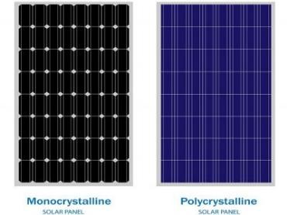
Figure 1. Solar cell panel
- Monocrystalline Solar Panels
Made from single-crystal silicon shaped into cylindrical form and pulled from molten silicon.
They have high efficiency, ranging from 16-25%.
Known for their excellent performance and long lifespan, despite being more expensive.
- Polycrystalline Solar Panels
Made from randomly arranged silicon crystals. They have efficiency around 14-16%.
Usually cheaper than monocrystalline panels, though their efficiency is slightly lower.

Solar Charge Controller (SCC)
Solar charge controller (SCC) is a component that regulates the charging of batteries using solar panels to optimize the process. This device controls the voltage and current of the charging based on the available power from the solar panels and the status of the battery charge (State of Charge, SoC). Generally, there are two main types of SCC widely used in solar power systems:

Pulse Width Modulation (PWM)
- PWM Solar Charge Controller (SCC) regulates battery charging using the pulse width of the on and off electricity, creating a waveform similar to a sine wave. The PWM controller operates at the battery's operating voltage, so if the voltage generated by the solar panel is below the battery's operating voltage, the solar panel system cannot charge the battery.
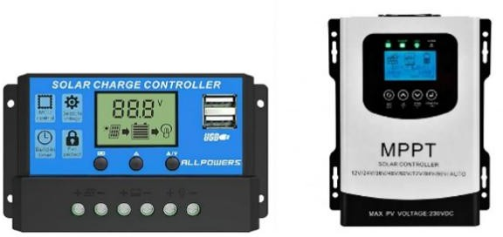
- Maximum Power Point Tracker (MPPT) SCC can store excess power that is not used by the load into the battery. If the power required by the load is greater than the power generated by the solar panel, additional power can be drawn from the battery. MPPT SCC is more efficient compared to PWM because it can maximize the power generated by the solar panel.
Figure 2. SCC PWM dan MPPT

Battery
A battery is an electrochemical device that stores energy and releases it in the form of electrical power. In solar power systems (PLTS), batteries are used as storage components for the direct current (DC) electricity generated by solar panels during the day. This stored energy is then supplied to electrical loads during the night or when the weather is cloudy.
There are various battery technologies available for solar power systems, such as lead- acid, lithium-ion, zinc-air, nickel-cadmium, and others. Lead-acid batteries are the most commonly used type in solar power systems due to their durability, safety, ease of use, and relatively low cost per cycle. Deep cycle lead-acid batteries are typically used because they can continuously discharge to near their nominal capacity.
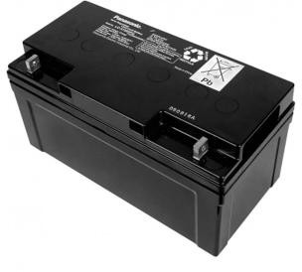

Figure 3. Lead Acid Battery

Research Methodology
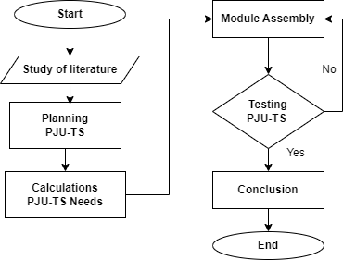
Figure 4. Flow Chart
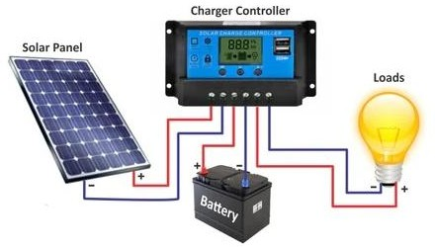
Figure 5. Set of Tools

Designing a Solar Power System (PLTS) Circuit for Lighting PLTS Circuit for Lighting

- Solar Panel (PV Module): The solar panel converts solar energy into DC electrical energy. The capacity of the solar panel must be sufficient to meet the power requirements of the lighting fixtures to be used.
- Solar Charge Controller (SCC): The SCC regulates the charging of the battery from the solar panel. It protects the battery from overcharging and ensures charging efficiency. The SCC capacity should match the current produced by the solar panel and the capacity of the battery used.
- Battery (Battery Bank): The battery stores the energy generated by the solar panel. It is essential for providing electricity when there is no sunlight or during nighttime.
- Inverter (Optional, depending on the type of lamps): If the lamps used require AC electricity (e.g., AC lamps), an inverter is needed to convert DC electricity from the battery into AC electricity.
- Lighting Fixtures: The lighting fixtures to be used should be compatible with the PLTS system you are designing. Ensure that the power rating of the lamps does not exceed the capacity of the designed system.
Steps to Assemble the Circuit:
  - Step 1: Connect the solar panel to the Solar Charge Controller (SCC) using cables suitable for the current capacity generated by the solar panel.
  - Step 2: Connect the output of the SCC to the battery. Ensure that the positive and negative polarity connections are correct to prevent damage to the SCC and battery.
  - Step 3: Connect the lighting fixtures to the battery. This can be done through an inverter if the lamps require AC electricity or directly if the lamps use DC electricity.
  - Step 4: Ensure all cable connections are strong and secure, and equipped with necessary protections such as switches to control the flow of electricity.

Results
Solar-powered street lamps with a 20-watt capacity harness solar energy as their power source. Sunlight received by the solar panels is converted into electricity and stored in solar cell batteries during the day. This stored electricity is then used to automatically illuminate the lamps at night when it gets dark. These solar street lamps can operate continuously for 12 hours or more.
Solar-powered street lamps also feature a system autonomy that lasts up to 3 days. This means the lamps have sufficient backup power to remain lit during adverse weather conditions without sunlight for up to 3 days, while still operating for 10-12 hours each day.

Table 1. Summarizes The Main Components and Specific Specification Description

LED Street Light 20 Watt 12/24 VDC
Solar Panel 60 WP
Solar Cell Battery 65 AH VRLA

Solar Cell Controller / BCR 10A, 12/24V, PWM

Solar Street Light Pole 7 meter Octagonal
Solar Panel Bracket Adjusted to Panel

Panel Box Single Battery Box + Clamp Box
Solar Panel Cable 2 x 2.5 mm

LED Street Light Cable 2 x 1.5 mm
Wiring Accessories Anti Climbing, Anchor, Bolt, etc.

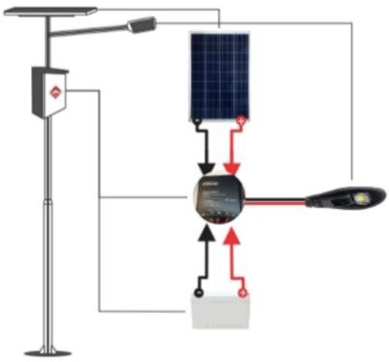
This table summarizes the main components and specific details regarding the operation of the 20-watt Solar-Powered Street Light system.
Figure 6. Set of tools PJU-TS

Calculation of Power Requirements
The electrical energy generated by Solar-powered Street Lighting (PJU-TS) cannot be utilized at 100% efficiency due to losses during transmission from the solar panels to the load. Therefore, an additional approximately 15% of the total power used is needed. Mathematically, for a load of 30 Watts, it can be outlined as follows:

- Total Power in Watts::
- 30 watt × 3 = 90 watt
- Total Power in Wh (Watt-hour):
- Total Power in Wh = 90 watt × 11 jam = 990 Wh
- Total Number of batteries = 0.8525 = 1
- Total Number of Panels = 1.98
- VRLA (Valve Regulated Lead Acid): 50.70%
- Total Power + Losses = 990 Wh+148.5=1138.5 Wh
With this adjustment, the power requirement calculation data for PJU-TS system becomes clearer and can be well understood in the context of efficient use of solar panel electrical energy for public street lighting.

Conclusion
Public street lighting (PJU-TS) plays a crucial role in urban planning. Beyond serving as nighttime navigation guides for road users, PJU also enhances the aesthetic value of an area and provides economic benefits.
Disruptions in PJU-TS are commonly caused by short circuits, main cable stripping, and damages to lamp housings or other PJU components. This emphasizes the importance of regular maintenance and inspections to prevent and promptly address issues.
To achieve maximum functionality in the installation of PJU-TS, attention to various aspects is necessary, such as selecting strategic installation points, determining appropriate pole heights for effective lighting, and choosing reliable and durable supporting components.

Acknowledgements
We would like to express our heartfelt thanks for your support and participation in this research. With your help and contributions, we have successfully completed the research with significant results. Every step we took and every conclusion we drew was driven by the outstanding collaboration from all parties involved. This research has not only yielded new insights but also opened up opportunities for further development in the future. Therefore, we want to thank you for your valuable time, thoughts, and contributions.

Reference
- Agostinelli, G., Batzner, D. L., & Burgelman, M. (2002). An alternative model for V, G and T dependence of CdTe solar cells IV characteristics. Proceedings of the 29th IEEE Photovoltaic Specialists Conference, 6, 744–747.
- Buchroithner, A., Gerl, B., Felsberger, R., & Wegleiter, H. (2021). Design and operation of a versatile, low-cost, high-flux solar simulator for automated CPV cell and module testing. Solar Energy, 228(August), 387–404. https://doi.org/10.1016/j.solener.2021.08.068
- Deepak, Srivastava, S., & Malvi, C. S. (2020). Light sources selection for solar simulators: A review. WEENTECH Proceedings in Energy, July, 28–46. https://doi.org/10.32438/wpe.060257
- Fauzi, F., Tajudin, M. F. N., Mohamed, M. F., Azmi, A., & Manaf, N. A. A. (2021). Assessment of in-house build low cost solar panel simulator. Journal of Physics:
Conference Series, 1878(1). https://doi.org/10.1088/1742-6596/1878/1/012038
- Frolova, T. I., Churyumov, G. I., Vlasyuk, V. M., & Kostylyov, V. P. (2019). Combined Solar Simulator for Testing Photovoltaic Devices. Proceedings - 2019 IEEE 1st Global Power, Energy and Communication Conference, GPECOM 2019, 276–280. https://doi.org/10.1109/GPECOM.2019.8778607
- Li, Q., Wang, J., Qiu, Y., Xu, M., & Wei, X. (2021). A modified indirect flux mapping system for high-flux solar simulators. Energy, 235, 121311. https://doi.org/10.1016/j.energy.2021.121311
- Liu, G., Ning, J., Gu, Z., & Wang, Z. (2021). Stability Test on Power Supply to the Xenon Lamp of Solar Simulator. Journal of Physics: Conference Series, 1820(1). https://doi.org/10.1088/1742-6596/1820/1/012142
- López-Fraguas, E., Sánchez-Pena, J. M., & Vergaz, R. (2019). A Low-Cost LED-Based Solar Simulator. IEEE Transactions on Instrumentation and
- Measurement, 68(12), 4913–4923. https://doi.org/10.1109/TIM.2019.2899513
- Moria, H., Mohamad, T. I., & Aldawi, F. (2016). Available online www.jsaer.com Research Article Radiation distribution uniformization by optimized halogen lamps arrangement for a solar simulator. 3(6), 29–34.
- Quandt, A., & Warmbier, R. (2019). Solar cell simulations made easy. International Conference on Transparent Optical Networks, 2019-July, 1–4. https://doi.org/10.1109/ICTON.2019.8840329

